DATABASE SYSTEMS ENGINEERING AND DISTRIBUTED BACKEND DEVELOPMENT

Practical Exercise 1 – Student Management REST API

Project Structure:

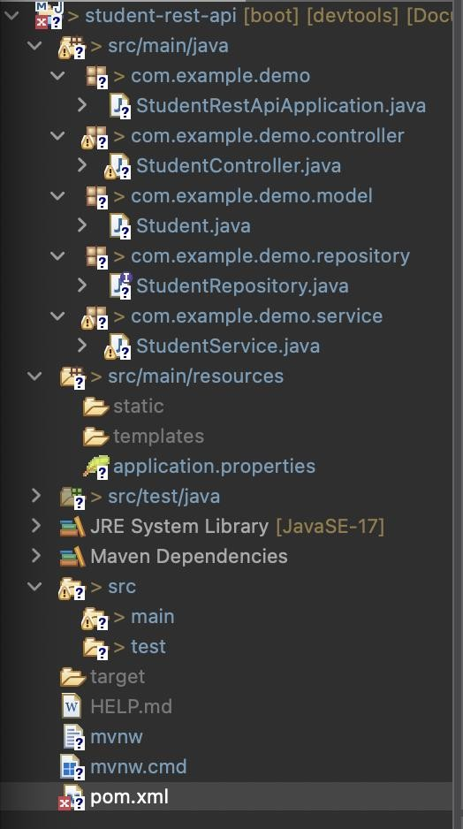

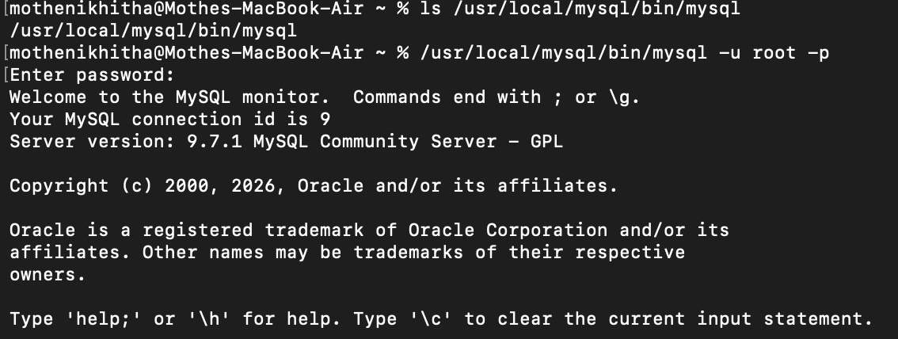
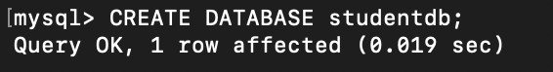
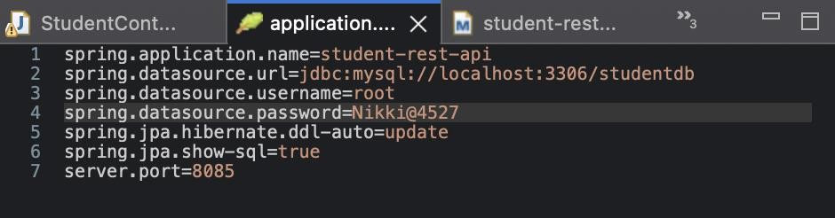
MySQL Server:

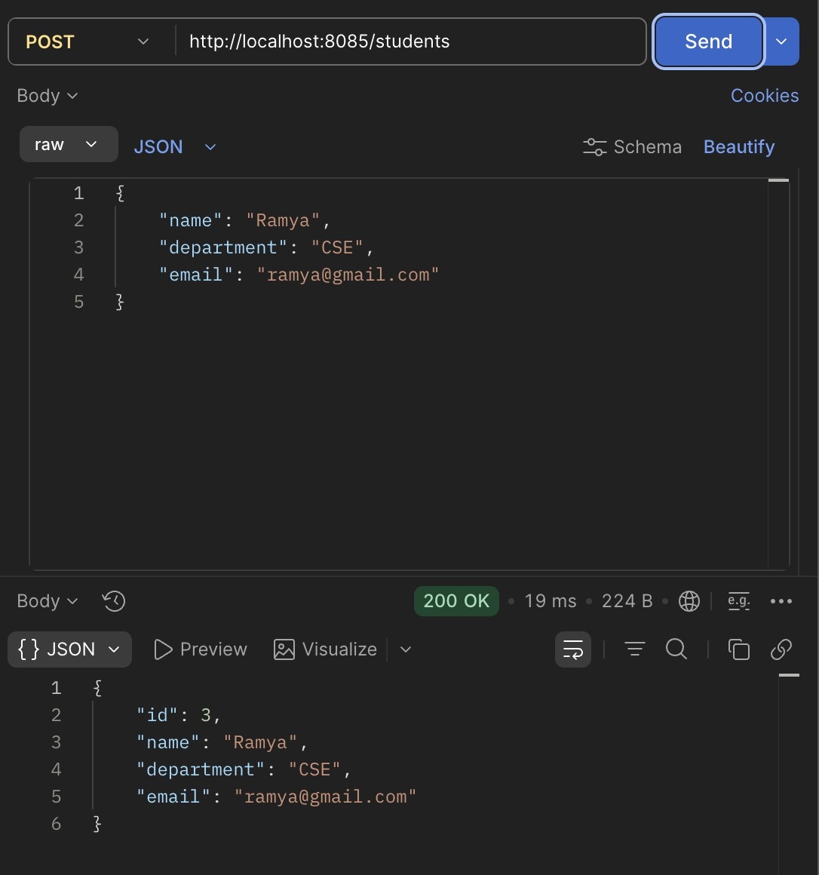
Postman:

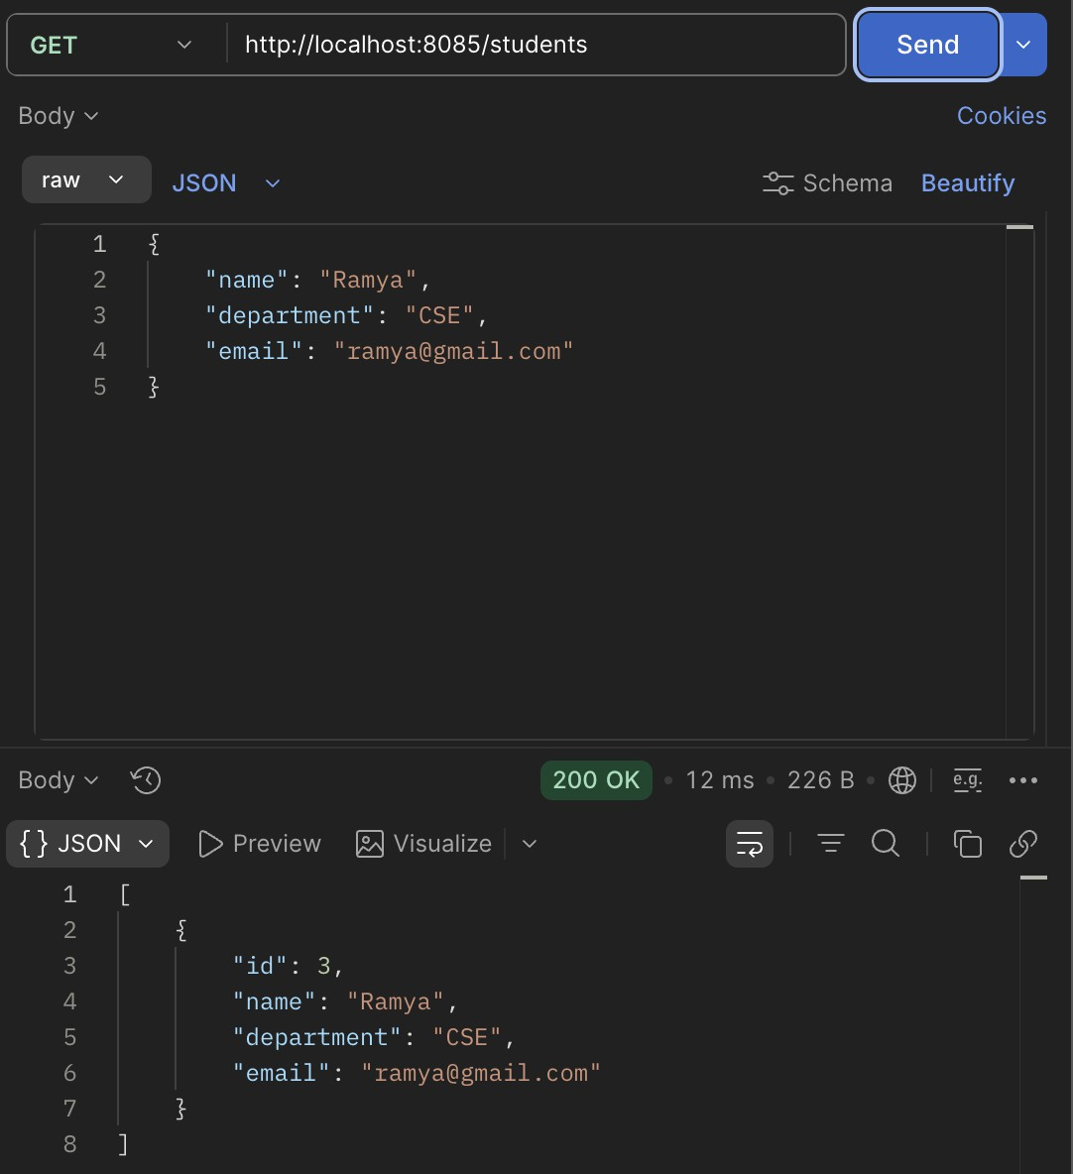

Test it with MySQL Server:

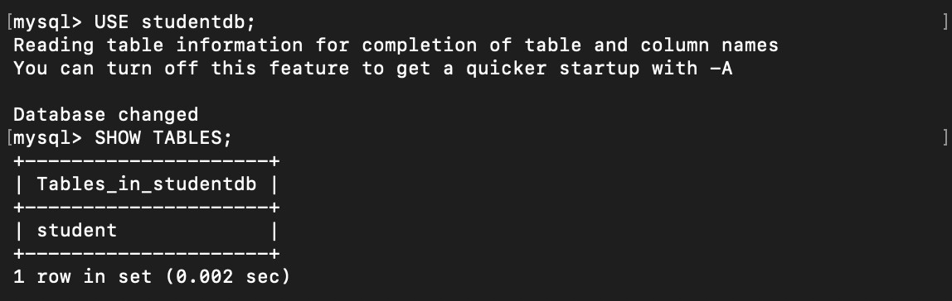
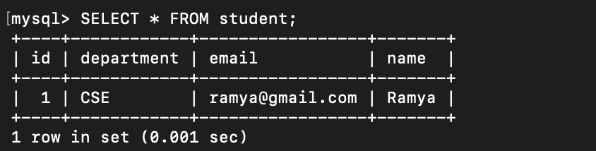

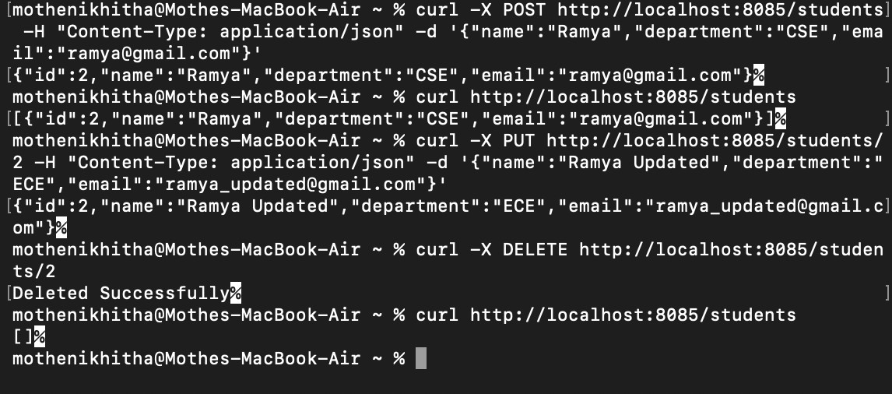
Testing with cURL:

